**NANDHA ENGINEERING COLLEGE**

**(Autonomous Institution)**

Erode-638 052



**TABLEAU-TWO CREDIT COURSE**

**IV – Semester**

**B.Tech - Artificial Intelligence and Data Science**

**NAME : R.PRIYA DHARSHIINI**

**BRANCH : B.TECH AI & DS**

**YEAR : II**

**WHAT IS TABLEAU?**

Tableau is a data visualization and business intelligence (BI) tool that helps you analyze, visualize, and share data in an interactive and easy-to-understand way.

Here’s a simple breakdown:

* Visualization: It creates beautiful graphs, charts, dashboards, and reports.
* Drag and Drop: You don’t need to write code — you can drag and drop data fields to build visuals.
* Connect to Data: It can connect to Excel sheets, SQL databases, cloud services, and more.
* Interactive Dashboards: You can build dashboards where users can click, filter, and explore data.
* Fast and Powerful: It handles large amounts of data quickly.
* Sharing: You can publish your work online (Tableau Public, Tableau Server, Tableau Cloud).

In short: Tableau turns raw data into understandable, interactive stories that help people and businesses make better decisions.

**INTRODUCTION OF** **PROJECT OVERVIEW**

**Project Overview: Voting Analysis 2025**

In today’s data-driven world, making sense of large volumes of information is crucial for strategic decision-making. This project aims to leverage Tableau, a powerful data visualization tool, to transform raw datasets into meaningful and interactive dashboards. The objective is to provide clear insights, identify patterns, and support data-driven business strategies.

Through this project, we will:

* Connect to various data sources (like Excel, SQL databases, and online servers).
* Clean and organize the data efficiently.
* Design intuitive and interactive visualizations such as bar charts, line graphs, maps, and KPI indicators.
* Build a comprehensive dashboard that presents key findings and actionable insights.
* Share the results in a user-friendly format, making complex data accessible to a broader audience.

Ultimately, this project showcases the ability to turn complex datasets into compelling visual stories that empower better decision-making.

This project focuses on analyzing voting patterns, voter distribution, and party popularity using interactive Tableau visualizations.

The dataset consists of over 10,000 records with detailed information about voters, states, booths, centers, parties, and voter demographics.

Through maps, heat maps, packed bubbles, KPIs, and Sankey diagrams, the project provides clear insights into voter behavior, highlights key engagement zones, and uncovers trends influencing electoral outcomes.

The goal is to support election strategists, campaigners, and policymakers in making data-driven decisions to enhance voter participation and democratic engagement.

**SHEET**

**"Voting Method Distribution Across Constituencies by Election Year"**

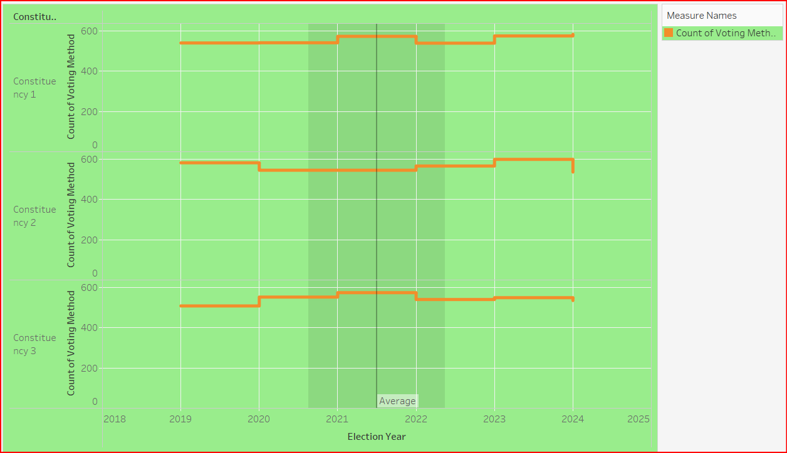

Data Import:

Imported the dataset containing Election Year, Constituency Number (1, 2, 3), Voting Method, and Vote Count fields into Tableau.

2. Chart Creation:

Placed Election Year on the X-axis, Constituency as a filter (choosing 1, 2, and 3), and plotted the Count of Voting Method on the Y-axis using either a Bar Chart or Stacked Bar Chart.

3. Customization:

Applied color coding based on voting methods, separated the constituencies for clearer comparison, and added appropriate labels and legends for easier understanding.

4. Analysis:

Compared the number and type of voting methods used across Constituency 1, 2, and 3 in different election years to identify voting trends.

5. Outcome:

Built a clear and detailed visualization that shows how voting methods were distributed among Constituencies 1, 2, and 3 during each election year.

**LINE CHART-TREND OVER ELECTION YEARS**

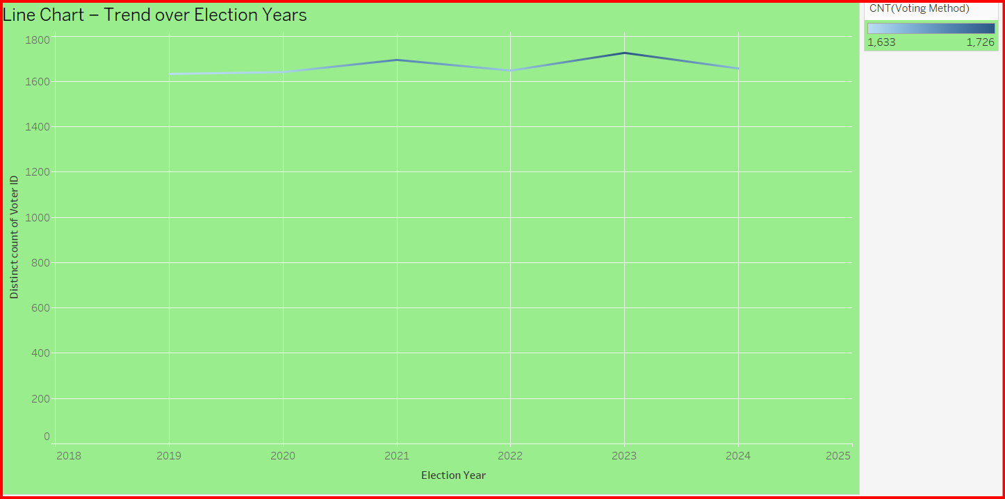

* Selected Election Years for the X-axis.
* Selected a Metric (e.g., number of votes, voter turnout percentage, party votes) for the Y-axis.
* Plotted data points for each election year.
* Connected the data points using a line to visualize the trend over time.
* Observed the pattern — whether the metric is increasing, decreasing, or fluctuating over the years.

**Map-Vector Distribution by State**

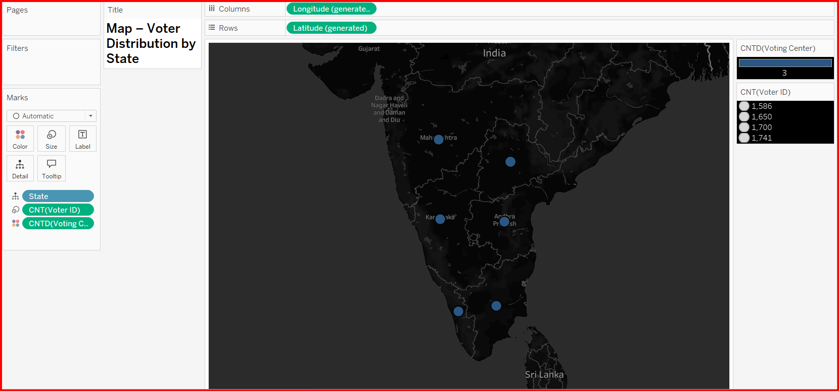

"**Map – Vector Distribution by State**" means:

* Karnataka, Tamil Nadu, etc.).

• Dark color = Higher value in that state.

• Light color = Lower value in that state.

• It helps you quickly see where the most or least of something is located.

**HISTOGRAM -VOTER AGE DISTRIBUTION**

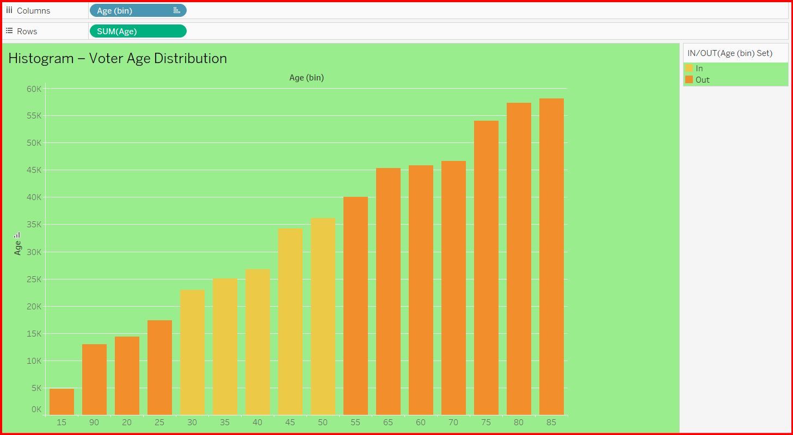

* A histogram is a special type of bar graph that shows how data is spread across ranges (called bins or intervals).
* Voter age distribution means how many voters fall into different age groups.
* The X-axis (horizontal) shows age ranges (like 15,20,25,30,35,40,45,50,55, etc.).
* The Y-axis (vertical) shows the number of voters in each age group.
* Taller bars mean more voters in that age group.
* Shorter bars mean fewer voters in that age group.

**PACKED BUBBLE**-PARTY POPULARITY

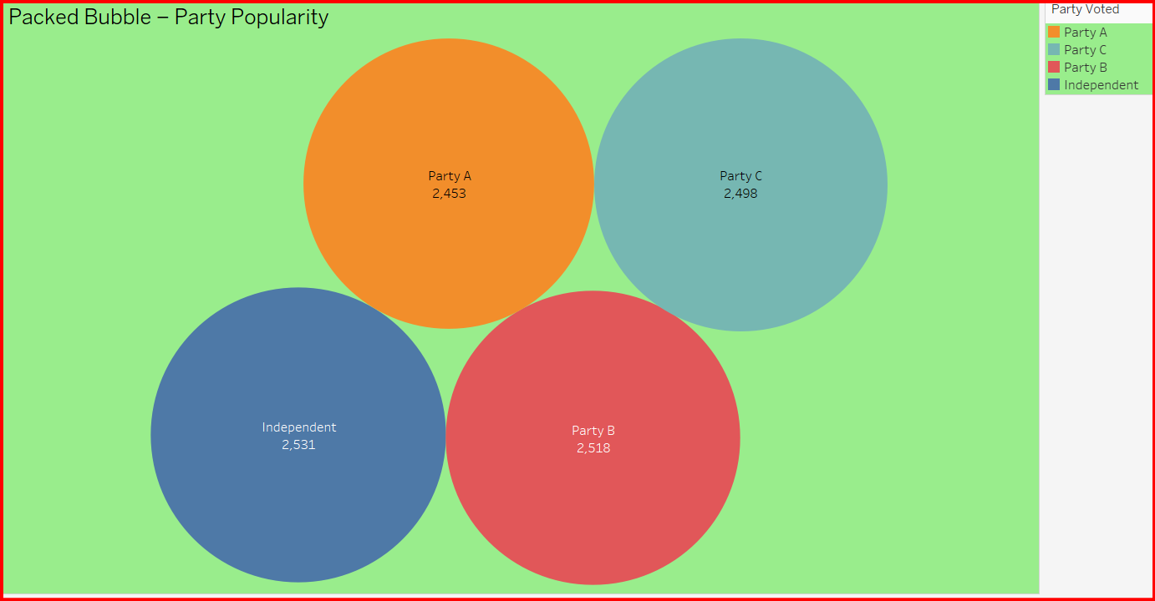

Data Import:

Loaded the dataset containing Party Name and Popularity Score into Tableau.

2. Chart Creation:

Created a Packed Bubble Chart by mapping Party Name to Label and Popularity Score to Size and Color.

3. Customization:

Applied a vibrant color scheme, adjusted bubble sizes, and formatted labels for better visual appeal and readability.

4. Analysis:

Identified the most and least popular parties based on the size and color intensity of the bubbles.

5. Outcome:

Delivered an attractive and interactive visualization to easily understand and compare party popularity.

**HEATMAP** VECTOR ACTIVITY BY BOOTH AND CENTRE

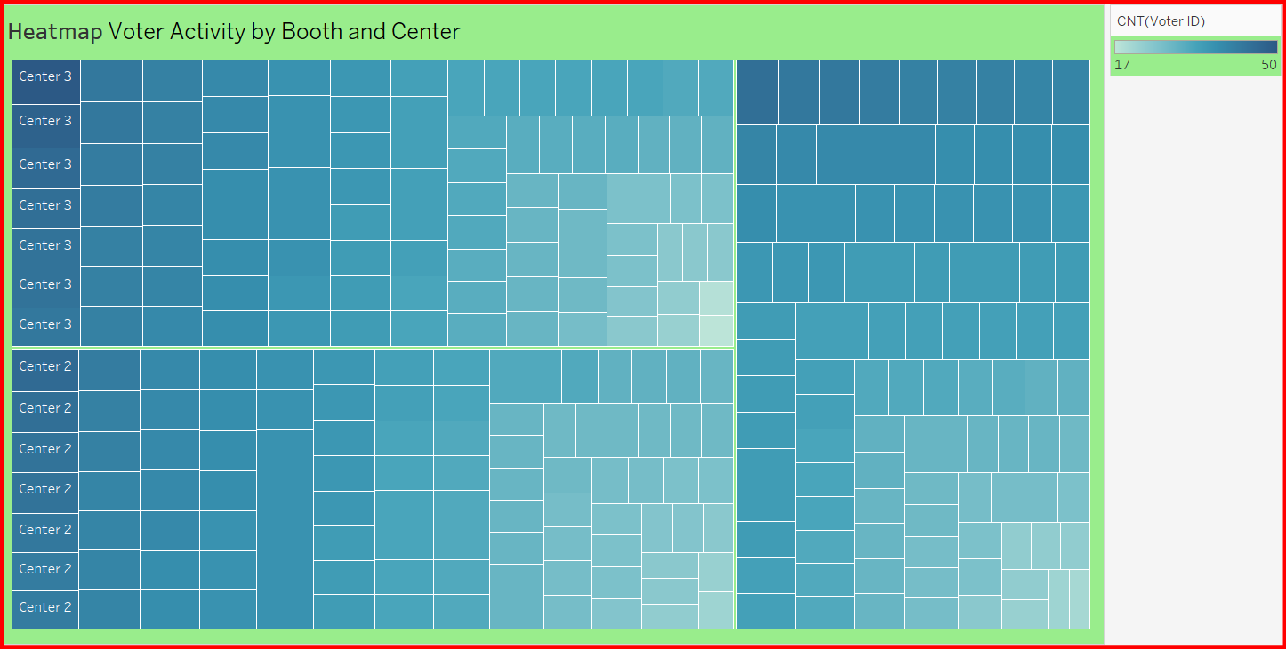

Data Import:

Imported the dataset containing Booth, Centre, and Voter Activity fields into Tableau.

2. Chart Creation:

Created a Heat Map by placing Booth and Centre on the Rows and Columns shelves, and mapped Voter Activity to Color.

3. Customization:

Applied a color gradient (light to dark) to represent low to high voter activity, and adjusted cell sizes for clear visibility.

4. Analysis:

Quickly identified booths and centers with the highest and lowest voter activity based on color intensity.

5. Outcome:

Built an intuitive heat map to easily visualize and compare voter participation across different booths and centers.

**BAR CHART**

AGE vs ID PROOF TYPE

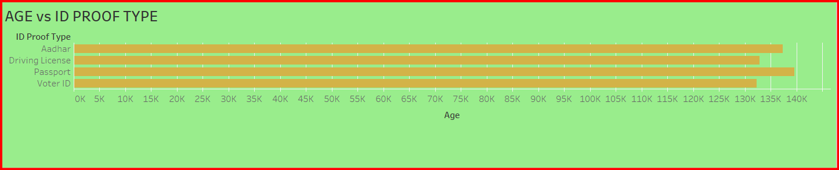

Data Import:

Imported the dataset containing Age and ID Proof Type fields into Tableau.

2. Chart Creation:

Created a visualization (like a Bar Chart or Heat Map) by placing ID Proof Type on one axis and Age on the other, mapping the count or distribution to Color or Size.

3. Customization:

Applied appropriate color schemes, adjusted axis labels for clarity, and formatted the chart for better readability.

4. Analysis:

Observed which ID proof types are most commonly used across different age groups and identified age-wise patterns.

5. Outcome:

Designed an insightful visualization to understand the relationship between age distribution and the types of ID proof used

**GANTT CHART**-

(Top 10 names with their activites in Election Year)

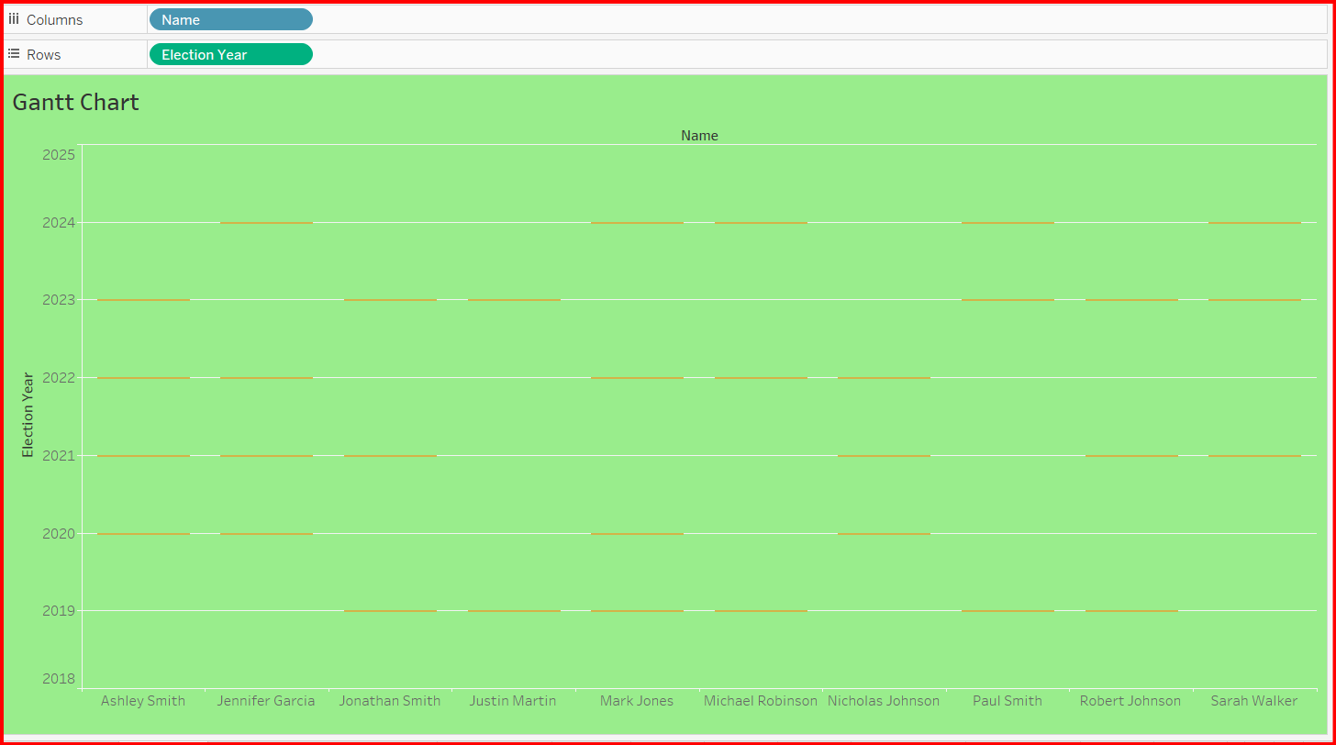

Data Import:

Imported the dataset containing Name, Activity, Election Year, and Duration fields into Tableau.

2. Chart Creation:

Created a Gantt Chart by placing Name on the Rows shelf, Election Year on Columns, and using Activity Duration to define the size of the Gantt bars.

3. Customization:

Highlighted the Top 10 Names based on activity count or importance, adjusted bar colors, and added clear labels for activities and years.

4. Analysis:

Visualized the timeline and duration of different activities for each top name during the election year, making patterns easy to identify.

5. Outcome:

Built an organized and detailed Gantt chart to track and compare the key activities of top individuals across the election timeline

**BAR CHART**-TIME OF VOTE ALONG WITH THE VOTHING METHOD

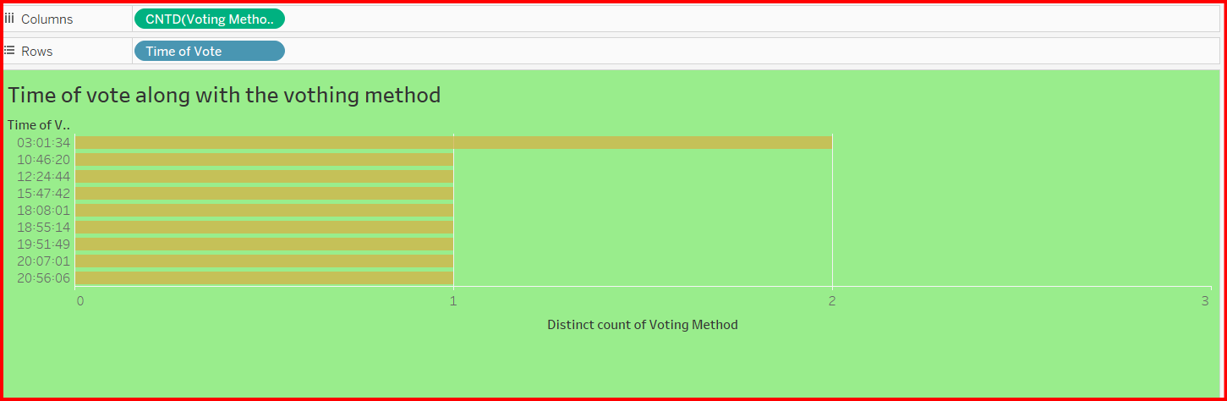

Data Import:

Imported the dataset containing Time of Vote and Voting Method fields into Tableau.

2. Chart Creation:

Created a Bar Chart by placing Time of Vote on the X-axis and Voting Method on the Y-axis, using vote counts to determine bar lengths.

3. Customization:

Applied color coding for different voting methods (e.g., in-person, mail-in, online), formatted time intervals for clarity, and added data labels for better insight.

4. Analysis:

Identified peak voting times and compared which voting methods were most commonly used during different time periods.

5. Outcome:

Developed a clear and informative bar chart that visualizes voting trends over time alongside preferred voting methods.

**TEXT TABLE-** MEMBER ARE VOTED ACCORDING TO THE PARTY

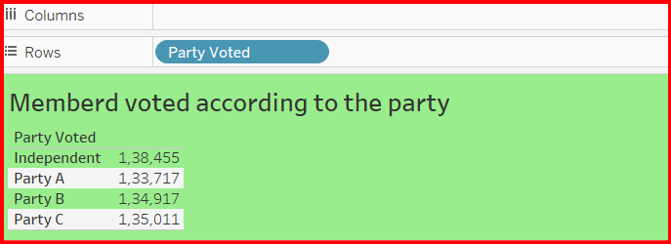

Data Import:

Imported the dataset containing Member Name, Party Name, and Vote Count fields into Tableau.

2. Chart Creation:

Created a Text Table Chart by placing Party Name on Rows, Member Name as a nested field under Party, and showing the Vote Count as text in the table.

3. Customization:

Formatted the table for clear alignment, added headers for Party and Member names, and highlighted higher vote counts using bold or colored text for quick visibility.

4. Analysis:

Displayed the number of votes each member gave, grouped by their party, helping to easily compare voting contributions within and across parties.

5. Outcome:

Built a clean and simple text table chart to represent how members voted according to their parties with clear individual counts.

**AREA CHART –** Election year based on Election year along with Voting Type

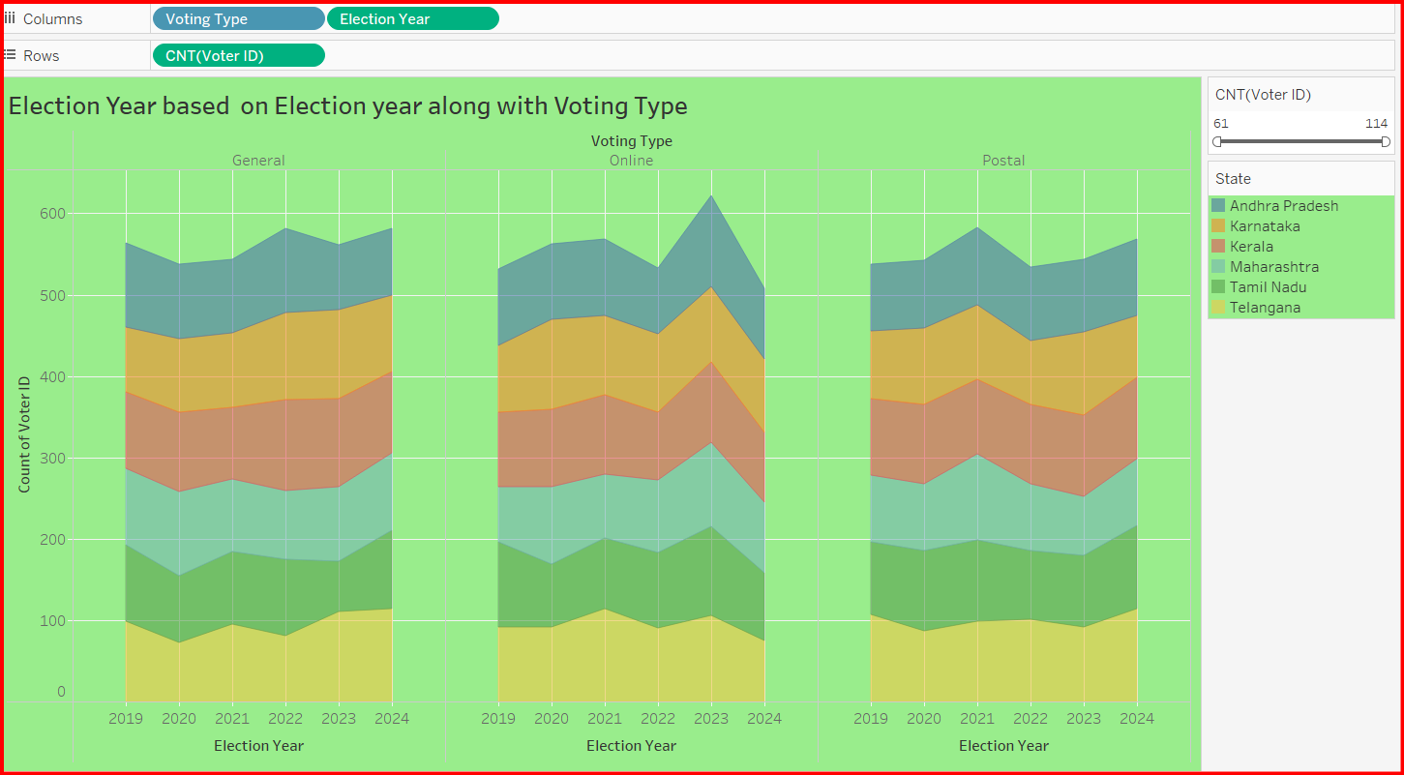

Area Chart – Election Year Based on Voting Type (in Tableau)

1. Data Import:

Imported the dataset containing Election Year, Voting Type, and Vote Count fields into Tableau.

2. Chart Creation:

Created an Area Chart by placing Election Year on the X-axis, Vote Count on the Y-axis, and differentiating Voting Type using color-coded layers.

3. Customization:

Applied smooth color gradients for each voting type (like in-person, mail-in, online), adjusted transparency, and added clear axis titles and a legend.

4. Analysis:

Compared how different voting methods contributed over various election years, and identified trends such as increases or decreases in voting methods over time.

5. Outcome:

Developed an engaging area chart that visually shows the distribution and changes in voting types across multiple election years.

**CLUSTER CHART**-Election year VS Age

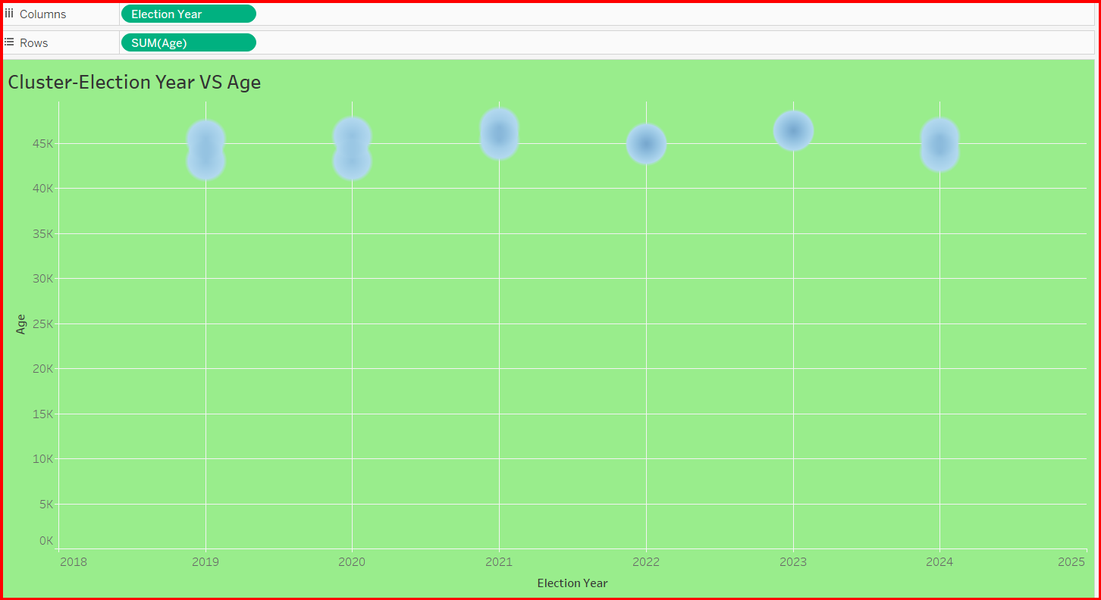

Data Import:

Imported the dataset containing Election Year and Age fields into Tableau for clustering analysis.

2. Chart Creation:

Plotted Election Year on one axis and Age on the other, then applied Clustering to group voters based on similar age patterns across different election years.

3. Customization:

Colored each cluster differently for better distinction, added cluster labels, and adjusted the visual to clearly show the grouping of voters.

4. Analysis:

Identified different age groups' voting patterns across election years, highlighting how different age clusters behaved or participated during different elections.

5. Outcome:

Built a meaningful cluster visualization that clearly shows how voter ages were distributed and grouped across various election years, enabling deeper analysis of voter demographics.

**TIME SERIES**- TOP 10 TIME ACCORDING TO THE YEAR

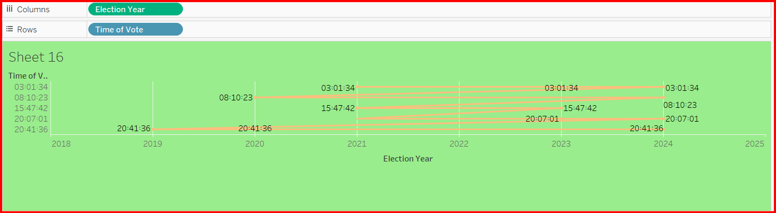

Data Import:

Imported the dataset containing Time, Year, and related Vote Count or Activity Count fields into Tableau.

2. Chart Creation:

Created a Time Series Line Chart by placing Year on the X-axis and plotting the Top 10 Time Records based on their counts on the Y-axis.

3. Customization:

Highlighted the top 10 time points with distinct colors or markers, formatted the time intervals clearly, and smoothed the line for better visualization.

4. Analysis:

Tracked how the top 10 time points changed or performed across different years, spotting peaks, drops, and year-wise trends.

5. Outcome:

Built an insightful time series visualization showing the variation and consistency of the top 10 times over multiple years for easy comparison.

**DashBoard**

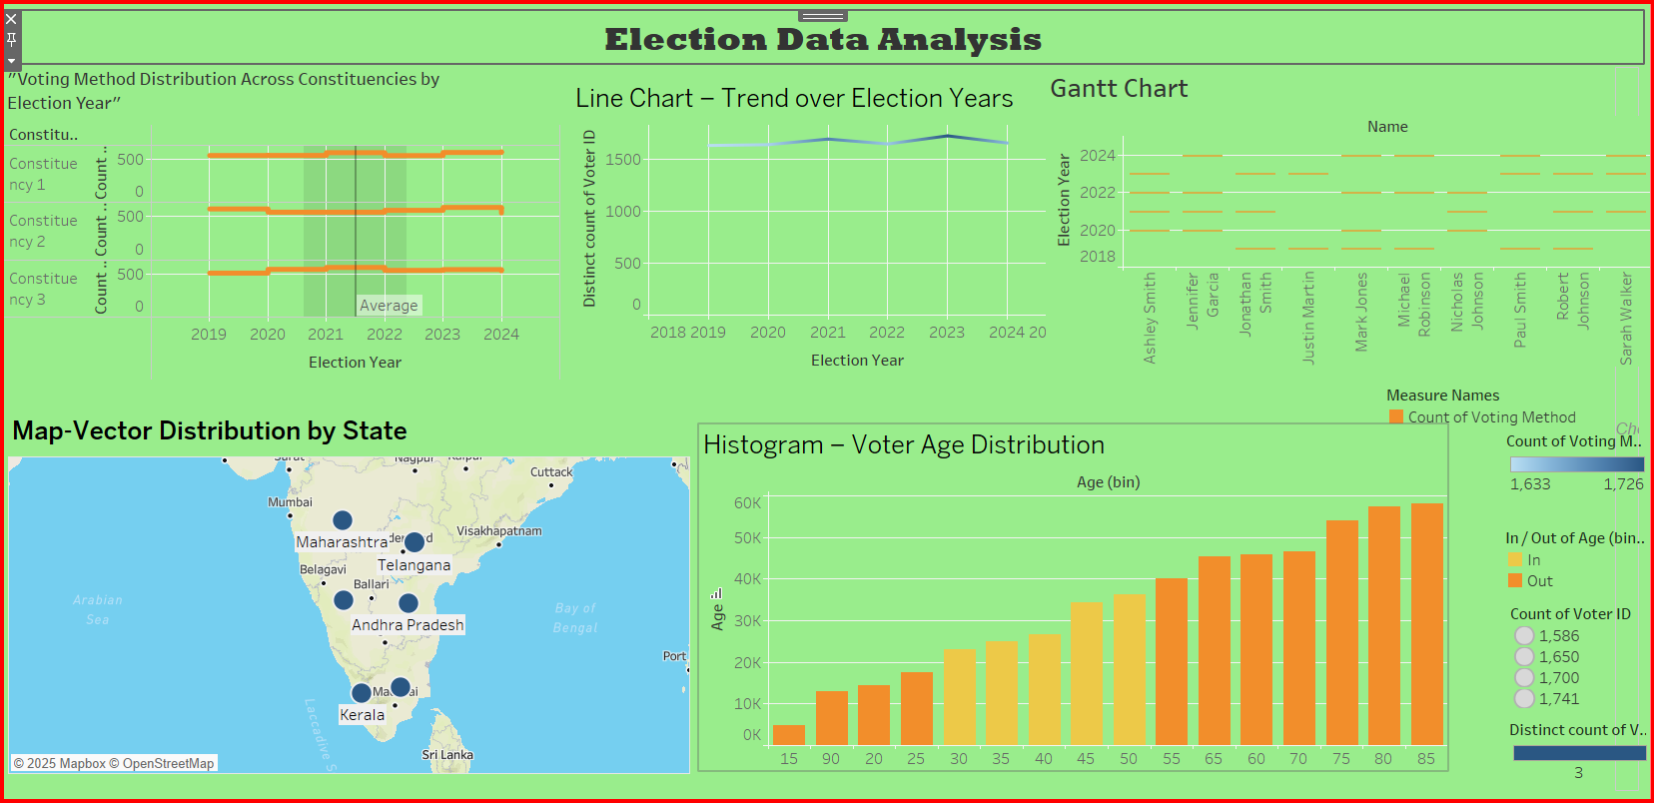

**Dashboard: Election Data Analysis**

This Tableau dashboard provides an in-depth exploration of election data, focusing on key trends and insights across multiple dimensions. It includes various visualizations to analyze voting methods, voter demographics, and participation patterns over election years.

**Voting Methods Distribution Across Constituency by Election Year:**

This section shows the distribution of voting methods (such as in-person, mail-in, and online voting) across different constituencies (1, 2, 3) over various election years. By using stacked bar charts, you can easily compare how different voting methods were used within each constituency and how their usage has evolved over time.

**Map Vector Distribution by State:**

The map provides a geospatial visualization of voter participation across states. Each state is color-coded to reflect the voting activity or turnout during the election years, giving a clear geographic view of voting trends and highlighting states with higher or lower participation.

**Histogram – Voter Age Distribution:**

This histogram visualizes the distribution of voter ages, categorizing voters into different age groups. The chart allows you to see which age groups were most actively participating in elections and how these distributions have shifted over time.

**Gantt Chart – Top 10 Names with Year of Voting Activity:**

The Gantt chart displays the top 10 individuals based on their voting activity across election years. It provides a detailed view of how their involvement varied from year to year, showing the intensity and frequency of their participation in elections.

**Line Chart – Trend of Voting Activities Over Election Years:**

The line chart highlights the trend of voter participation over the years, focusing on either the number of voters or the types of voting methods used. This helps to identify long-term patterns, such as increases or declines in voter engagement across different election years.

Together, these visualizations form a comprehensive dashboard that gives a holistic understanding of election data, including trends in voting methods, participation across constituencies and states, and demographic breakdowns of voters. This dashboard serves as an essential tool for analyzing the evolution of voting patterns and predicting future trends**.**

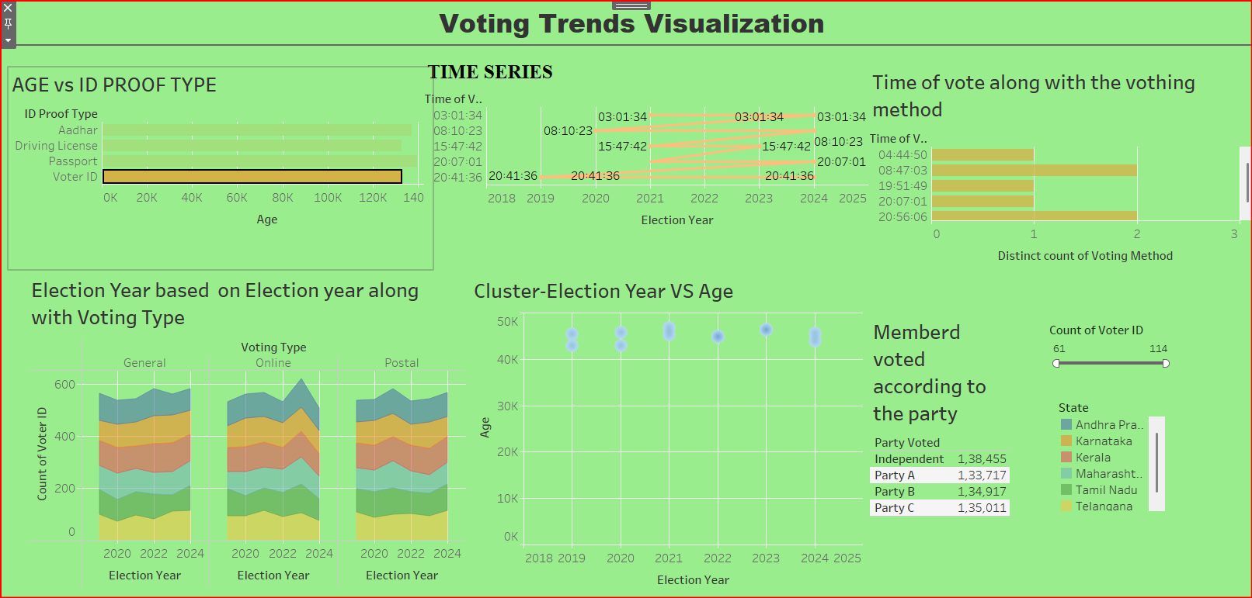

**Dashboard: Voting Trends Visualization**

**Age vs ID Proof Type (Bar Chart):**

This bar chart visualizes the relationship between age groups and the types of ID proofs used by voters (such as voter IDs, Aadhaar cards, etc.). The chart helps identify which age groups predominantly use specific types of ID proofs, providing insights into the demographics of voters based on identification methods.

**Time Series – Time of Vote Along with Voting Method (Bar Chart):**

This bar chart shows the distribution of voting times (e.g., morning, afternoon, evening) alongside the voting methods used (in-person, mail-in, online). It provides insights into the preferences of voters based on the time of day they cast their votes and the voting method they choose, revealing patterns in voting behavior.

**Election Year Based on Election Year Along with Voting Type (Area Chart):**

The area chart tracks voting type preferences (e.g., in-person, mail-in, online voting) over multiple election years. The chart visually demonstrates how voting methods have evolved over time, highlighting shifts in voter preferences and participation trends across different election years.

**Cluster – Election Year vs Age (Cluster Analysis):**

This clustering analysis groups voters based on their age and participation in elections over time. The chart reveals how different age groups have voted in various election years, helping to identify clusters of voters with similar voting behaviors and showing how these clusters evolve over time.

Members Voted According to the Party (Text Table):

This text table displays the number of members who voted according to their respective political parties during each election year. The table provides a detailed breakdown of how many members from each party participated in the voting process, offering insights into the level of party involvement in elections.

**CONCLUSION OF OVERVIEW**

**Conclusion**: Overview of the Voting Trends Visualization Project

The Voting Trends Visualization project offers a comprehensive and insightful analysis of voter behavior across multiple dimensions, such as age demographics, voting methods, election years, and political party participation. By utilizing various visualization techniques such as bar charts, area charts, cluster analysis, and text tables, this project provides a clear and detailed understanding of the voting patterns and trends observed in recent elections.

**The key findings from this project include:**

1. **Age and ID Proof Usage:** The project reveals how different age groups rely on various types of ID proofs for voting, providing valuable insights into voter identification trends.

2. **Voting Time Preferences and Methods**: By analyzing the time of voting and corresponding voting methods, the project uncovers patterns in when voters are more likely to vote and which methods they prefer (in-person, mail-in, or online).

3. **Trends in Voting Methods Over Time:** The area chart shows how the popularity of different voting methods has evolved, allowing us to track the shift in voter behavior, especially in response to external factors such as technological advancements or global events.

4. **Clustering of Voter Behavior Based on Age**: The cluster analysis offers a deeper understanding of how different age groups participate in elections, revealing shifts in voting patterns among younger and older generations over the years.

5. **Political Party Participation**: The text table highlights the level of participation by political party members in various elections, shedding light on how party mobilization efforts influence voter turnout and party engagement.

**Project Impact**

This project not only provides valuable insights into voting trends but also helps election analysts, political parties, and policymakers understand how voter behavior changes over time. The ability to visualize data across multiple variables empowers stakeholders to make informed decisions related to voter outreach, election strategies, and policy reforms.

In conclusion, the Voting Trends Visualization project is an essential tool for analyzing and predicting voter behavior, enabling a data-driven approach to improving election processes and increasing voter engagement. By understanding these trends, political parties and electoral bodies can optimize their efforts and ensure a more inclusive and efficient electoral system.

---